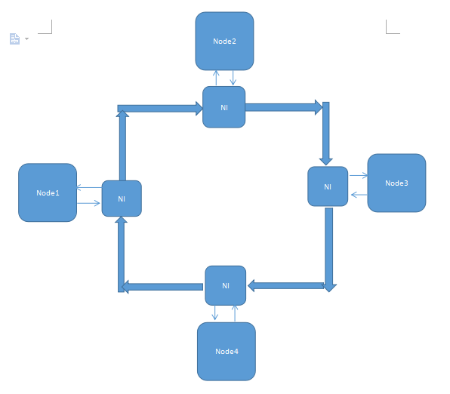

Scalable Multi-Core Processor with Ring Network and Shared Memory Space Support.

Shaomin Zhai

XiDian University

Computer Architecture Final Project Report

2016/3/24

**Abstract**

Due to fundamental physical constraints, the rate of growth of central processing unit clock speeds is beginning to fall short of the predictions set forth by Moore’s Law. As a result,researchers are now exploiting the performance gains possible from multi-core processing.

This project aims to introduce some of the difficulties presented by multi-core computing and what is needed to achieve an operational multi-core system.

**Key word: scalable, reply-forwarding, ring network, credit-flow control, diectory-based cache coherence, Shared address space.**

**0.Introduction**

As you know, Processor design needs to consider power, area, and clock frequency. For parallel computer architecture, what should also be considered,is that delivery mechanism plurality of core network architecture, cache coherence protocols, network bandwidth, network message. All of these factors affect our decision to design processor architecture, and micro-architecture, which finally affects performance, price and power consumption of a processor. Whlie this gives us a lot of design space, but also brings us a lot of problems that can be analysed and solved by processor model including software model and hardware model. These two models are both necessary for designing processor ,here I need some hardwares to demonstrate my project.

**I wil appretiate if you are willing to give financial assistance to me for my project! I’ll need about 20 thousand RMB ,which will be used for project devices, books, materials, consulting fee , service fee and so on, as the subvention of my project.**

In a shared memory multiprocessor system where each processor has its own data memory cache,care must be given to make sure that each processor receives correct data from its cache,regardless of how other processors may be affecting that memory address.

When the following two conditions are met,the cache correctly handles the memory accesses across the multiple processors,and is called cache coherent:

1, A value written by a processor is eventually visible to other processors

2, when multiple writes happen to the same location by multiple processor, all the processors see the write in the same order.

There are two general categories of cache coherency protocols:

1, Directory based protocols: where a single location keeps track of the status of memory blocks;

2, Snooping protocols: where each cache maintains the status of memory blocks and monitors activity from the other processors’ caches.updating the status of the memory blocks if necessary.

A protocol is further specified as either write-invalidate,where a write to a memory location by one processor invalidates the corresponding cache line,if present,in the other processors’ caches; or write-update, where the other processors update the data in their caches rather than invalidating them.

The protocols that I will implement and investigate for this project will be a MESI write-invalidate directory based protocols with write-back caches.

Agenda:

1,block diagrams of whole system

2,Overview of Directory-Based Approaches ,message format and interconnection network

3.benchmarks

4.future work and extentive

5.conclusion and suggestion.

6.refrences

Appendix

**1.Implementation Topology**

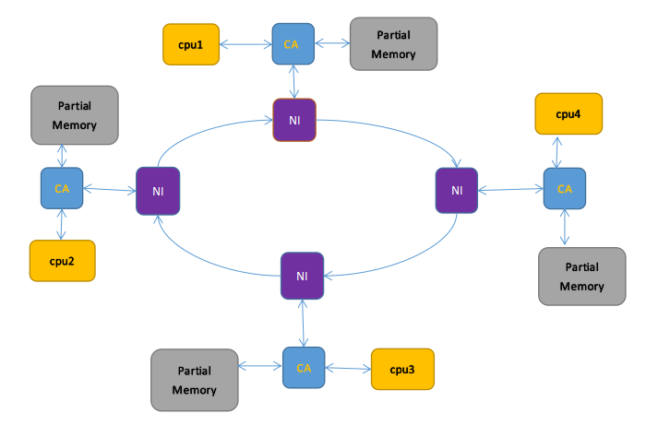

Fig. 1 Block diagram depiction of the hardware

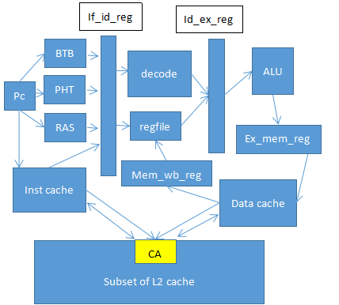

Fig.2 Block diagram depiction of cpu

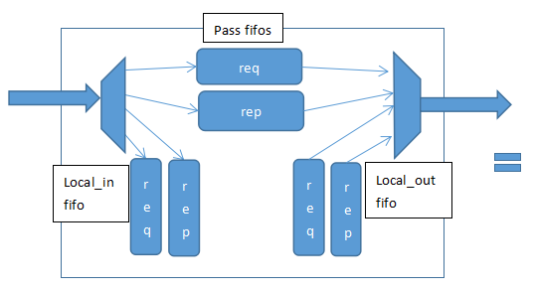

NI

Fig 3 block diagram of network interface(NI).

Communicate

assist

Arbiter_for_IN_node

Arbiter_for

_out_rep

Arbiter_for

_out_req

Dc_req_

upload

Mem_req

_upload

Mem_req

_upload

Ic_req_

upload

Mem_

download

Dc_down

load

Ic_down

load

Dc_req_

upload

Data cache

Subset of L2

Inst cache

From pipeline of core

Fig 4 block diagram of communication assist(CA).

**2 Overview of Directory-Based Approaches**

This section begins by describing the directory scheme and how it might operate using cache states,directory states, and network transaction. It discusses the issues in state transition

Diagram , directory structure and protocol lever correctness one by one.

The following definitions will be useful throughout our discussion of directory protocols.For a

Given cache or memory block:

The **home** node is the node in whose main memory the block is allocated.

The **dirty** node is the node that has a copy of block in its cache in modified (dirty)state.Note

That the home node and the dirty node for a block may be the same node.

The **exclusive** node is the node that has a copy and that block in its cache in an exclusive state,either dirty or exclusive-clean.Thus, the dirty node is also the exclusive node.

The **local** node ,or requesting node, is the node containing the processor that issues a request

For the block.

The **owner** node is the node that currently holds the valid copy of a block and must supply the data when needed; this is either the home node,when the block is not in dirty state in a cache,or the dirty node.

Blocks whose home is **local** to the issuing processor are called locally allocated(or some- times simply local)blocks,while all others are called remotely allocated(or **remote**).

**2.1 some states of transition**

**Cache states:** For each cache line, there are 5 possible states:

C-invalid (= Nothing): The accessed data is not resident in the cache.

C-shared (= Sh): The accessed data is resident in the cache, and possibly also cached at other sites. The data in memory is valid.

C-modified (= Ex): The accessed data is exclusively resident in this cache, and has been modified. Memory does not have the most up-to-date data.

C-transients(= read-Pending/write-pending): The accessed data is in a *transient* state (for example, the site has just issued a protocol request, but has not received the corresponding protocol reply).

**Home directory states:** For each memory block, there are 4 possible states:

R(*dir*): The memory block is shared by the sites specified in *dir* (*dir* is a set of sites). The data in memory is valid in this state. If *dir* is empty (i.e., *dir* = ε), the memory block is not cached by any site.

W(*id*): The memory block is exclusively cached at site *id*, and has been modified at that site. Memory does not have the most up-to-date data.

TR(*dir*): The memory block is in a transient state waiting for the acknowledgements to the invalidation requests that the home site has issued.

TW(*id*): The memory block is in a transient state waiting for a block exclusively cached at site *id* (i.e., in C-modified state) to make the memory block at the home site up-to-date.

**Base messages from MIT lecture notes( more details in refrence).**

Messages:

Cache to Memory requests: ShReq, ExReq

Memory to Cache requests: WbReq, InvReq, FlushReq

Cache to Memory responses: WbRep(v), InvRep, FlushRep(v)

Memory to Cache responses: ShRep(v), ExRep(v)

Operations on cache:

cache.state(a) -returns state s

cache.data(a) -returns data v

cache.setState(a,s), cache.setData(a,v), cache.invalidate(a)

inst = first(p2m); msg= first(m2c); mmsg = first(in)

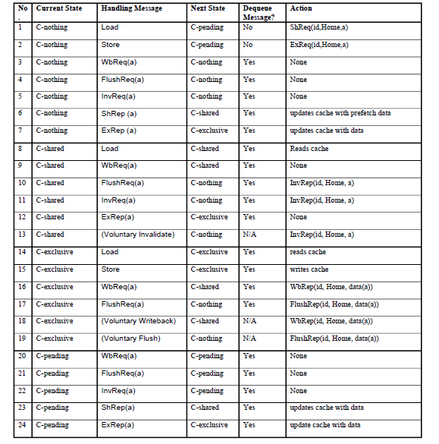

Table 1,Cache State Transitions

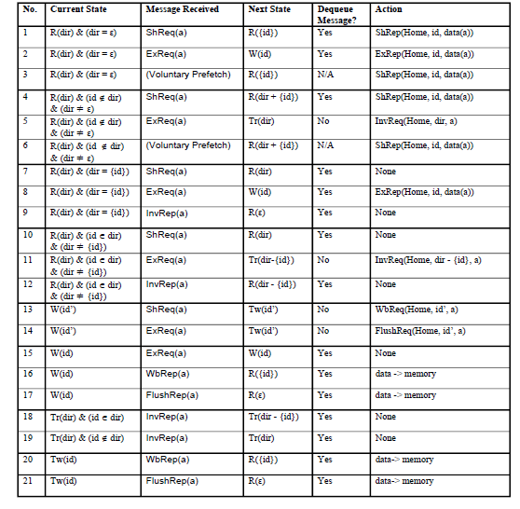

Table 2,Home Directory State Transitions, Messages sent from site id

**Note content of section 2.1 is from Arvind Computer Science and Artificial Intelligence Lab M.I.T. November 14, 2005 lecture notes**

**2.2 The following rules is used in reply-forwarding (which is my effort)**

**Background: protocol optimization**

In general, there are three classes of techniques for improving performance:

(i) protocol optimization ,

(ii) high-level machine organization,

(iii) hardware specialization to reduce latency and occupancy and increase bandwidth.

I want to use the first technique to reduce messages and critical transaction path.

Here are 3 kinds of options for me to try.

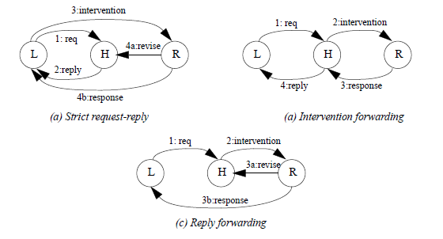 fig 5. Reducing latency through forwarding

The case shown is of a write request in node 1 to a block in shared state.let’s assume node2,node3,node4 all share the data.L represent the local (requesting) node,H is the Home for block,and R is the remote owner node that has the exclusive copy of the block.

**Message passing in section 2.1 from MIT is based on strict request-reply.while what I want to implemente is a reply-forwarding message passing ,which will be demonstrate to be more efficient than strict request-reply message passing.**

Because this system is a distributed-memory system,Every node has a partial memory ,so when a read-miss or write-miss arrives at communication assist,the CA will translate the physical address into a node id ,which can be used to find the destination node ,and a local address that will be used to look up information at home node,then use the node-id to check whether the miss will be handle locally or remotely. Of course, if the home node is the same as the requesting node, then no network transactions or messages are generated and it is a locally satisfied miss.

For (a) strict request-reply option,the CA in local node finds that it needs to generate a request (process 1)to the remote home,when the state in the cache line is invalid or shared,or the value indexed by address is not in the cache. When the request arrives at home node,the CA will decode the message to look up the directory states and find there are some other nodes sharing the data . Then the CA will change shared to TR(dir)(dir={0,1,1,1}) waiting for invalidation responses returning of node2,3,4 and send reply including data back to local (requester) node with dir{0,1,1,1} information(process 2),Which will be used by local node to send 3 invalidation requests to NI,further to the corresponding node(process 3).note the the first request still in the home FIFO or other storage component used for the final state set for node1’s write request.when the intervention(noted by 3) arrives at remote nodes ,the nodes immediately change the state in their cache from shared to invalid,in the meantime sending back invalidation responses back to local node and revision to home node.once the local node receive all the needed responses ,it can actually write the data,and then local CA is able to process nest request.

When home node receive all revisions required,it is able to change the state from TR(dir) to W{1,0,0,0}.

For (b) intervention forwarding ,once the home node receive the request,it will forward 3 invalidation requests directly to the shared nodes to tell them to invalid their share data.when the invalidation requests get to shared nodes,the responses will be sent to the home node telling him that the shared data is already invalided,then the home node can send response to local node telling it is able to do the real write.

For (c) reply forwarding ,refer to (b),once the remote node receives the intervention,it then send revise to home node to change state from TR{0,1,1,1} to W{1,0,0,0},also send reply including data directly to local node

In conclusion,it seems the third option can get best optimization.

(a)strict request-reply has 4 critical transactions and 1+1+3+3+3=11 messages totally.

(b)intervention forwarding has 4 critical transactions and 1+3+3+1=8 messages totally.

(c)reply forwarding has 3 critical transactions and 1+3+3+1=8 messages totally.

Since reply forwarding seems good,I will apply it to my project.

**2.3 .Combine reply-forwarding with basic rules**

**Cache side rules**

**Load -hit rule**

**If Load (a)==inst & cache.state(a)is sh or ex**

**Then p2m.deq**

**M2p.enq(cache.data(a))**

**Load -miss rule**

**If load(a)==inst & cache.state(a) is nothing**

**Then c2m.enq(msg(id,home,shreq,a))**

**Cache.setstate(a,pending)** //blocking cache left request in p2m FIFO

//when the transactions done ,need to the

// do the same thing like load-hit rule!

// so must FIFO order to promise correct!

**Store -hit rule**

**If store(a,v)==inst& cache.state(a)is EX**

**Then P2m.deq;**

**M2p.enq(ack)**

**Cache.setdata(a,v)**

**Store -miss rule**

**If store(a,v)==inst & cache.state(a) is nothing or sh**

**Then c2m.enq(msg(id,home,exreq,a));**

**Cache.setstate(a,pending)**

**// If store(a,v)==inst & cache.state(a) is sh**

**// Then c2m.enq(msg(id,home,upgrade,a));**

**Cache.setstate(a,pending)**

//blocking cache left request in p2m FIFO

//when the transactions done ,need to the

// do the same thing like load-hit rule!

// so must FIFO order to promise correct!

**Processing shreq messages(at home node)**

**Uncached or outstanding shared copies**

**if Msg(id,home,shreq,a)==mmsg & m.state(a) is R(dir)& id not in dir**

**Then inhome.deq;** // don’t need further requests to accomplish.

**M.setstate(a,R(dir+id));**

**Out.enq(msg(home,id,shrep,a,m.data(a)))**

**Outstanding Exclusive copy**

**If mmsg==msg(id,home,shreq,a) & m.state(a) is W(id’) &(id!=id’)**

**Then m.setstate(a,Tw(id’));**

**Outhome.enq(msg(home,id’,wbreq,a,id))** *//the node id’ will directly send*

*// reply (with data) to the requester*

*//and revise to home .*

*//Then local cache will p2m.deq(inst)*

*//and home node will inhome.deq(mmsg)! While in the meantime the processor //has to wait for completion and cache controler can’t handle more inst,*

*//and in addition, inhome FIFO has to wait for the head msg to complete.*

**Processing EXreq messages (at home node)**

***Uncahched or cached only at the requester cache***

***If mmsg==msg(id,home,exreq,a) & m.state(a) is R(dir) &(dir is empty or has only***

***id)***

***Then in.deq***

***M.setstate(a,W(id))***

***Outhome.enq(msg(home,id,exrep,a,m.data(a)))***

***Outstanding shared copies***

***If mmsg==msg(id,home,exreq,a) & m.state(a) is R (dir) &!(dir is empty or has only id)***

***Then m.setstate(a,Tr(dir-id))***

***Outhome.enq(multicast(home,dir-{id},invreq,a,id))***

***\*\*\*\*\*\*\*\*\*\*note :Outhome.enq(msg(home,id,sh->exrep,a,m.data(a),***

***INVRep_vector))***

*//* ***sh->exrep should be treat differently in cpu side cache controler!***

*//note:when the reply_forwarding msg*

*//arrives at node id,the id can’t write data until all the needed*

*//invresps get to the id.this is actually* ***reply forwarding!***

***Outstanding Exclusive copy***

***If mmsg==msg(id,home,Exreq,a) & m.state(a) is W(id’) &(id’!=id)***

***Then m.setstate(a,Tw(id’))***

***Outhome.enq(msg(home,id’,flushreq,a,id))*** *//note: when this msg arrives at //node id’ ,the id’ change its cache state to inv,and send Exrep msg with data to //id.meanwhile send flushrep to home ,then home change state to W(id).*

**Processing reply messages (at cache)**

**Shrep**

***If msg=={msg(home,id,shreq,a,v) or msg(id’,id,wb->shrep,a,v)}*** *&(cache.state(a) must be pending or nothing)*

***Then m2c.deq***

***Cache.setstate(a,sh)***

***Cache.setdata(a,v)***

**Exrep**

***If msg=={ msg(home,id,Exrep,a,v)***

***or msg({dir-id},id,sh->exrep,a,m.data(a))***

***or msg(id’,id,flush->exrep,a,v) } &*** *(cache.state(a) must be pending or nothing)*

***Then m2c.deq***

***Cache.setstate(a,EX)***

***Cache.sedata(a,v)***

*// since one outstanding at any given time,i think i can drop address in the reply //msg,which can cut down the number of flits.Assume flits has 16 bits,then we can*

*//reduce 2 flits average when need to rerply! I think it’s a good idea to improve ipc.*

**Processing InvReq message (at cache)**

**InvReq**

***If msg==msg(home,id’’,InvReq,a,id) & cache.state(a) is sh***

***Then m2c.deq***

***Cache.invalidate(a)***

***C2m.enq(msg(id’’,id,InvRep,a))***

***C2m.enq(msg(id’’,home,InvRep,a))***

***If msg(Home,id,InvReq,a) == msg&cache.state(a) is Nothing or Pending***

***Then m2c.deq*** //occurs when the shared data was evicted before!

**Processing WbReq message (at cache)**

**wbReq**

***If msg==msg(home,id’,wbreq,a,id) & cache.state(a) is EX***

***Then m2c.deq***

***Cache.setstate(a,sh)***

***C2m.enq(msg(id’,home,wbrep,a,cache.data(a)))***

***C2m.enq(msg(id’,id,shrep,a,cache.data(a)))***

***If msg==msg(home,id’,wbreq,a,id) & cache.state(a) is sh or nothing or pending***

***Then m2c.deq***

**Processing Flushreq message**

**Flushreq**

***If msg==msg(home,id’,flushreq,a,id) & cache.state(a) is EX***

***Then m2c.deq***

***Cache.invalidate(a)***

***C2m.enq(msg(id’,home,flushrep,a,cache.data(a)))***

***C2m.enq(msg(id’,id,exrep,a,cache.data(a)))***

**Note:because use NACKs to avoid multiple request on the same block ,the following two cases shouldn’t happen in the system!**

***/**************************************************************** If msg==msg(home,id’,flushreq,a,id) & cache.state(a) is sh***

***Then m2c.deq***

***Cache.invalidate(a)***

***C2m.enq(msg(id’,home,exrep,a)***

***C2m.enq(msg(id’,id,exrep,a))***

*// I think this case occur when ex_cache evict the cache line ,*

*//then read again in its cache during home send flushreq .*

***If msg==msg(home,id’,flushreq,a,id) & cache.state(a) is nothing or pending***

***Then m2c.deq***

***Cache.invalidate(a)***

***C2m.enq(msg(id’,home,flushrep,a,cache.data(a)))***

***C2m.enq(msg(id’,id,exrep,a,cache.data(a)))***

*//after home sends flushreq,owner evicted the exclusive cache line*

*//so remain in nothing/then read it again but hadn’t received data,*

*//so remain pending .*

***\*\*\*\*\*\*\*\*\*\*\*\*\*\*\*\*\*\*\*\*\*\*\*\*\*\*\*\*\*\*\*\*\*\*\*\*\*\*\*\*\*\*\*\*\*\*\*\*\*\*\*\*\*\*\*\*\*\*\*\*\*\*/***

**Processing Reply invRep message (at home)**

**InvRep**

***If mmsg==msg(id,home,InvRep,a,id’) & m.state(a) is Tr(dir)***

***Then deq mmsg***

***If(dir!=id)***

***M.settstate(a,Tr(dir-{id}))***

***Else M.setstate(a,W(id’))***

*// now dir doesn’t include requester id! Here id’=requester id*

***If mmsg==msg(id,home,InvRep,a) & m.state(a) is R(dir)***

***Then deq mmsg***

***M.seetstate(a,R(dir-{id}))***

*// note: this can happen when a cache line in sh state is evicted.*

*// the cache controler should generate this InvRep msg.*

**Processing Reply WbRep message (at home)**

**wbRep**

***If mmsg==msg(id,home,wbRep,a,v) & m.state(a) must be Tw(id) or W(id)***

***Then deq mmsg***

***M.setstate(a,R(id))***

***M.setdata(a,v)***

**flushRep**

***If mmsg==msg(id,home,auto->flushRep,a,v) & m.state(a) must be W(id)***

***Then deq mmsg***

***M.setstate(a,R(empty))***

***M.setdata(a,v)***

***If mmsg==msg(id,home,flushRep,a,v,id’) & m.state(a) must be Tw(id)***

***Then deq mmsg***

***M.setstate(a,W(id’))***

***M.setdata(a,v)***

**2.4 message format**

**Having understood rules about actions in home and cache, i need to encode these msgs for correctness. The msgs sent between nodes have following formats: 0 1**

**Changed message categories** encode cmd 4’bxxxx cache or home

Cache to Memory requests: ShReq: **msg(id,home,shreq,a) 5’b00000 1**

ExReq: **msg(id,home,exreq,a) 5’b00001 1**

**ScExReq:msg(id,home,ScExreq,a) 5’b00010 1**

**InstReq:msg(id,home,InstReq,a) 5’b00110 1**

Memory to Cache requests: WbReq:***msg(home,id’,wbreq,a,id) 5*’b00011 0**

InvReq:***msg(home,id’’,InvReq,a,id) 5*’b00100 0**

FlushReq:***msg(home,id’,flushreq,a,id) 5*’b00101 0**

**Sc->Invreq:msg(home,id’,scINVreq,a,id)5’b00110 0**

Cache to Memory responses: WbRep(v):***msg(id,home,wbRep,a,v) 5*’b10000 1**

invRep:***msg(id,home,C2HInvRep,a) 5*’b10001 1**

FlushRep(v) :***msg(id,home,flushRep,a) 5*’b10010 1**

flushfail_rep:***msg(id,home,flushfail,a)* 5'b10110 1**

**//**id of this kind is requester id,which launch the transition

wbfail_rep:***msg(id,home,wbfail,a)* 5'b10111 1**

**//**id of this kind is requester id,which launch the transition

*Auto->flushRep:****msg(id,home,auto->flushRep,a,v) 5’b10011 1***

cache/memory to Cache responses:

Wb-> sh-> ShRep(v):***msg(id’/home,id,shrep,a,cache.data(a)) 5*’b11000 0**

Flu-> R(id)-> ExRep(v):***msg(id’/home,id,exrep,a,cache.data(a)) 5*’b11001 0**

Sh-> ExRep(v):***msg(home,id,exrep,a,cache.data(a),INV_vector) 5*’b11010 0**

**scFlushrep:msg(home,id,scFlushrep) 5’b11100 0**

**InstRep:msg(home,id,Instrep,v) 5’b10100 0**

**Cache to cache responses:**

**invRep:msg(id’,id,C2CInvrep,) 5’b11011 0**

**Flit has 16 bits!**

**The head flit contains :dest_id[15:14] ,**

**cacheORhome1[13], //cache :0 ;home :1;**

**src_id[12:11],**

**cacheORhome2[10],**

**cmd[9:5],**

**requester_id(if needed)[4:3],**

**[3:0] requried INVREP vector.**

**Example:[3:0]={1,1,0,0}, meaning cache in node3 and cache in node2 need to reply the IvnReps.**

**Since only 4 nodes 2 bits for id ,that’s enough! cacheORhome indicate whether home id or cache id.**

**The body flits are address flits (If needed,determined by cmd)**

**and data flits (If needed,determined by cmd).**

**Along with flit links, there will be some control signals to guide flits flow through the network.**

**The ring links are short,wide,and synchronous. Each unidirectional link is 16 data bits ,2 ctrl bits, 8 credit flow ctrl bits(reverse direction compared with others). Flits are 16 bits. 2 ctrl bits identify the flit type (00 :no info, 01:head flit, 10:body flit, 11:last body flit).8 credit flow ctrl bits are divided into two 4-bits flow ctrl signals, one for unused slots in downsteam pass req fifo ,the other for pass rep fifo.**

**The credit flow ctrl bits are crucial for avoiding deadlock, In the meantime, avoiding overflow of donwstream fifos . Now let’s study a case !**

arbiter

4

3

2

1

**select**

reg

Pass req

Pass req

**1 5**

Pass rep

Pass rep

**2 6**

IN

req

IN

rep

OUTrep

OUTreq

3 4 7 8

Ctrl==2’b11?compete again :not compete.

**2.5.Deadlock free**

**T**i means time flow. **Can_cmpt** means deadlock free and can compete with others.

The trangles noted by number stand for busy flag . When 1 is true ,it means pass req is currently busy transfering his flits to next node.

|  |  |  |  |  |  |
| --- | --- | --- | --- | --- | --- |
|  | 1 | 2 | 3 | 4 | Competition describtion |
| T1 | 1 | 1 | 1 | 0 | 1 win for 7 already. Pass Rep2 has been transfering flits to pass rep 6.  Ctrl of flit from pass rep2 now is 2’b11. Next cycle pass rep 6 is free to be copmeted among pass rep 2 and OUT rep 4(if deadlock free). |
| T2 | 1 | 0 | 1 | 0 | Now 2 and 4 both find that 6 free . Head flit tell 4 go to pass rep 6 instead of IN rep 8. And 4 finds there are enough slots for it to store its flits. Then 4 win for the right to access 6,according to some priority algorithm. Then arbiter set busy flag 4 |
| T3 | 1 | 0 | 1 | 1 | ...........transfering flit according round robin algorithm  ( At this time, 1,3,4 transfer flits in turn). |
| ..... | 1 | 0 | 1 | 1 | ...........transfering flit according round robin algorithm |
| T4 | 1 | 0 | 1 | 1 | 4 finishes transfering to 6, that’s ctrl==2’b11. Then arbiter rst the busy flag 4. |
| T5 | 1 | 0 | 1 | 0 | 4 win for 8 and 2 win for 6(no competition between 4 and 2). And  Ctrl of rep 3’s flit == 2’b11. Then arbiter sets busy flag 2 and 4, rsts 3. |
| T6 | 1 | 1 | 0 | 1 | 3 can’t win for 5,because of lacking of deadlock free condition.(the first msg in OUT req3 have bigger number of fllits than the nunber of unused slots in req 5). |
| ..... | 1 | 1 | 0 | 1 | ..........transfering flit according round robin algorithm |
| T7 | 1 | 1 | 0 | 1 | Now 3 win for 5 after long time 5 pop some flits to next node of it. So there is enough unused slots now (deadlock free). |
| T8 | 1 | 1 | 1 | 1 | 1，2，3，4 transfer flits in turn (RR algorithm). |

**Think carefully**

Once we let 3 win for 5, then 3 will fill up 5 with its flits while there are some flits still in 3.

Assuming at this time, deadlock occurs between nodes like the figure below

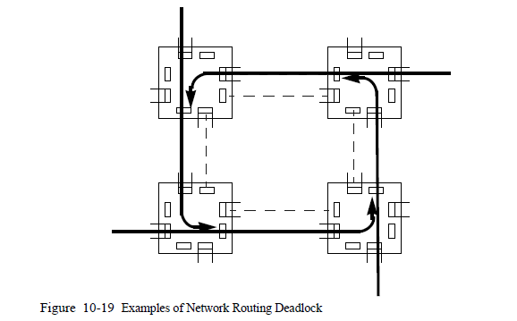

**NOTE**: once there is possibility of deadlock between pass fifos ,at this time every pass fifo should have at least one unused slot for receiveing flit from previous node. we only allow pass fifos transfering between each other. So as long as flits flow to their dest node , the pass fifos will grandually become deadlock free for IN fifos to send out flits to pass fifos of next node.

**Reason** why T6 situation happens is that once we change transfer source from OUT fifos to pass fifos ,we may lose the correctness of the OUT fifo’s message. Because msg will be divided into two part among nodes. The frame of the splited msg will be wrong for dest node’s msg process logic, and the logic need to NACKs to src node to retry. In this project, i prefer to provide deadlock free to reduce NACKs to improve porformance. While NACKs still might happen,when a node request a busy addr in the dest node, dest node NACK to src node to retry again after a short time depending on retry algorithm in the src node.

Since number of bits including head flit ,addr and data is more than 16 and cache or mem process whole mssage everytime, you may wonder how flits generate and transfer from node to ring network. There are some serial-parallel assist for donwloading flits from network to dest cache or mem, and parallel-serial assist for uploading flits from src cache or mem to network.

Figure below will tell you how it works!

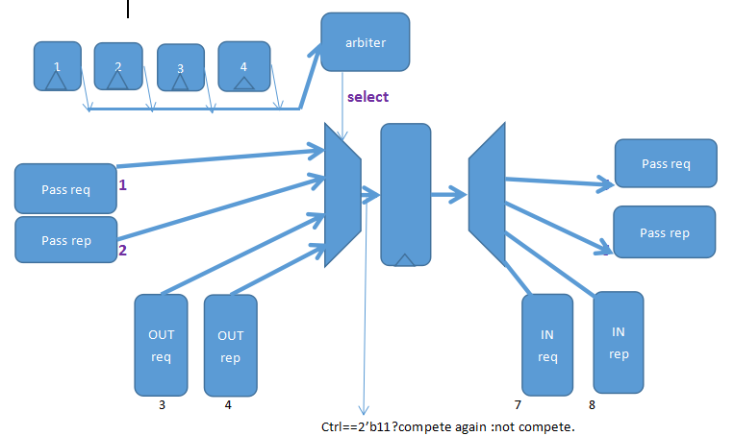

Arbiter

upload

FSM

|  |  |  |  |
| --- | --- | --- | --- |
| head | addrHI | addrLO |  |
| Data1HI | Data1LO | Data2HI | Data2LO |
| Data3HI | Data3LO | Data4HI | Data4LO |

Download

FSM

|  |  |  |
| --- | --- | --- |
| head | addrhi | addrlo |
| Data1hi | Data1lo | Data2hi |
| Data2lo | Data3hi | Data3lo |
| Data4hi | Data4lo |  |

Register file

State_tag ram and data ram

Cache FSM

The block diagram above still works for mem transaction!

Other than the use of reply forwarding, the most interesting aspects of the protocol are its

use of **pending** states and **NACK**s to resolve race conditions and provide serialization to a location,and the way in which it handles race conditions caused by writebacks.

**NOTE**:

1,pending states: these imply that the home has received a previous request for that block, but was not able to complete that operation itself (e.g. the block may have been dirty in a cache in another node); transactions to complete the request are still in progress in the system, so the directory at the home is not yet ready to handle a new request for that block.

2,NACKs: when the CA receive a request to the block which is in progress due to previous request, the CA should drop the later requests and wait for them to retry.

**3 core**

**3.1 Branch predictor**

**Contianing 3 structures: BPT(branch predictor table)**

**BTB(branch target table)**

**SRS/RAS(subroutine return stack/return address stack)** 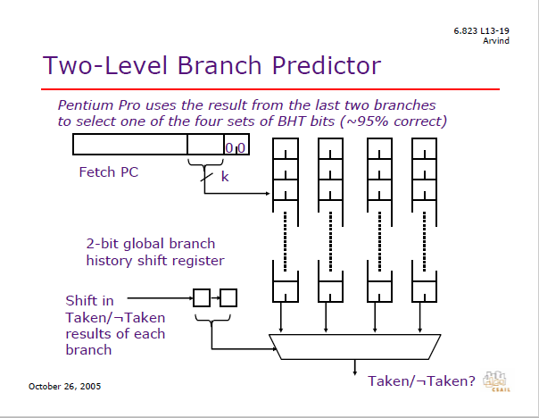

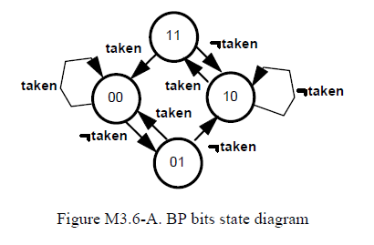

**Figure from MIT 6.825 course**

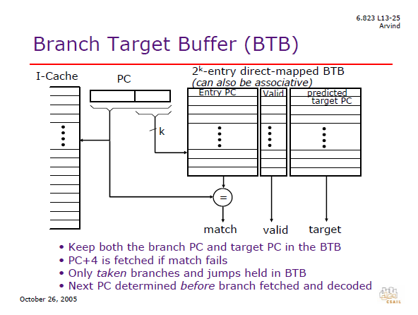

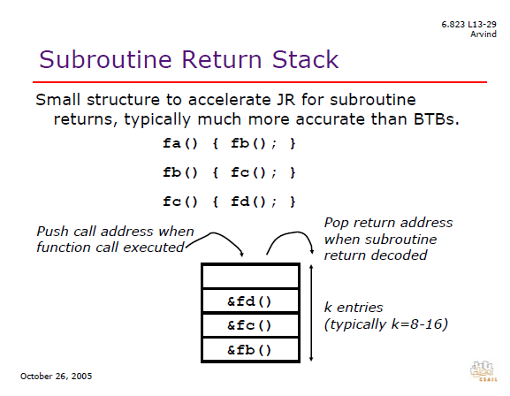

In order to make the best use of hardware available, cpu designers tend to explore the space of design via running benchmarks on the target cpu high level model (eg.gem5,simplescalar), here the space for branch predict engine(BPE) including:

num of RAS entry;

Num of BTB entry;

Num of BTB tag bits;

Num of BTB way;

Num of PHT entry;

Num of BHR entry;

Num of BHR bits(history length).

Since I am famliar with gem5, I will use it to determine the parameter of BPE.

**3.2 benchmarks for core parameter(BPE, caches)**

median qsort towers vvadd dijkstra stringsearch

**3.3 Resource Constrained Design Problem**

In this portion of the lab, you will try to design the best branch predictor given certain constraints on the hardware resources available to you. Your design constraints are as follows:

*Assume I am not allowed to use more than 1024 bytes of total state for branch predictor(except for RAS)

*Assume computation costs nothing. Be as crazy as you want to.

Branch Predictor design exploration table:

|  |  |  |  |  |  |  |  |
| --- | --- | --- | --- | --- | --- | --- | --- |
| v | btb  tag | BTB  target | BTB  type | Left  Reg  bits | 2bits  Local  (predcitor_size*  bits/ctr) | tournamentBP  localTableSize*bits/counter；  localHistSize  *bits/HistReg；  globalTableSize  *bits/counter；  choiceTableSize  *bits/counter. | BiModeBP  globalPredictorSize*  globalCtrBits;  choicePredictorSize*  choiceCtrBits |
| 1  bits | 15  bits | 30 bits | 2 bits | 128*16 | 2048*1  /1024*2 | 128*2;128*7;  128*2;128*2 | 512*2  512*2 |
| 1  bits | 16  bits | 30 bits | 2 bits | 128*15 | 1024*1  /512*2 | 128*2;128*7;  128*2;128*2 | 256*4  256*2 |
| 1  bits | 17  bits | 30 bits | 2 bits | 128*14 | 1024*1  /512*2 | 128*2;128*7;  128*2;128*2 | 256*4  256*2 |
| 1  bits | 18  bits | 30 bits | 2 bits | 128*13 | 1024*1  /512*2 | 128*2;128*7;  128*2;128*2 | 256*4  256*2 |

How to do it?

I use Minor cpu model of Gem5 with 2bits local BP, Tournament BP, Bimode BP by

Running programs of section 3.2 to drive the exploration.

Since the result of BPE design exploration simulation for BTBtagsize(16,17,18) is identical because of no effection of incrementting BTBTagSize, here I only analyse the result of BTBTagSize equalling 15 and 16.

**Here I correct some mistakes in the chart:**

**programs 2 bits local stands for BTBTagSize15 2bits local ,**

**BTBTagSize15 2 bits local stands for BTBTagSize16 2bitslocal.**

|  |  |  |  |  |  |  |
| --- | --- | --- | --- | --- | --- | --- |
| programs |  | BTBTagSize15 |  |  | BTBTagSize16 |  |
|  | 2bits local | tournament | BiMode | 2bits local | tournament | BiMode |
| dijkstra | 1.69782 | 1.68813 | 0.88067 | 1.69778 | 1.68813 | 1.69033 |
| median | 1.14362 | 1.11243 | 1.02526 | 1.11003 | 1.11243 | 1.1133 |
| qsort | 1.24589 | 1.2733 | 1.04835 | 1.24401 | 1.2733 | 1.27924 |
| search | 1.06184 | 1.04722 | 0.74967 | 1.07215 | 1.04722 | 1.05759 |
| tower | 1.27084 | 1.22125 | 1.07198 | 1.25765 | 1.22125 | 1.25235 |
| vvadd | 1.1276 | 1.04492 | 0.93762 | 1.02008 | 1.04492 | 1.14831 |
| geometric  mean | 1.24258 | 1.21363 | 0.94523 | 1.21548 | 1.21363 | 1.24147 |

Note: BENCHMARKratio is the program execution time ratio of my benchmarks which is introduced in section 3.2.Here I correct some mistakes in the chart:

programs 2 bits local stands for BTBTagSize15 2bits local ,

BTBTagSize15 2 bits local stands for BTBTagSize16 2bitslocal.

Obviously in the table BTBTagsize15 2bitlocal beats others, so I should choose **BTBTagsize15 2bitslocal** way in my cpu core to implement a better BPE.

**4.benchmarks for showing performance improment**

In order to demonstrate porformeance improvment from single to multicore processor ,I will use several benchmark to feed the system.

**4.1** memory benchmark,which can be used to test the data transport proformance.

**4.2** binary search algorithm (a classic divide and conquer algorithm) that searches for a value X in an sorted N-element array A and returns the index of matched entry,which is from Computer Organization and Design: The Hardware/Software Interface, Fifth Edition.

**4.3** sum of a array, which can be implemented on multicore easily.

**4.4** merge_sort algorithm.

**5. future work&extentive**

Since the complexity of computer system is increasing rapidly, it force us to explore design space from many different points, we now need to build a powerful platform to support our explore. Here I want to make my project more useful ,which is scalable and parameterized.

Parallel computer architecture bring us additional exploration space ,such as network bandwidth,cache coherence protocal, message passing rules , Network router strategy and network interface fifo depth besides design space of single core design.

**network bandwidth (which can affects message format,)** : typecally 16 bits, 32 bits, 48 bits etc.

**cache coherence protocal** : snooping-based ; directory-base.

**message passing rules**:strict request-reply; intervention-forwarding; reply-forwarding.

**internetwork topology :** ring(I fucos on), mesh, linear array.

**Network router strategy .**

**Network interface fifo depth.**

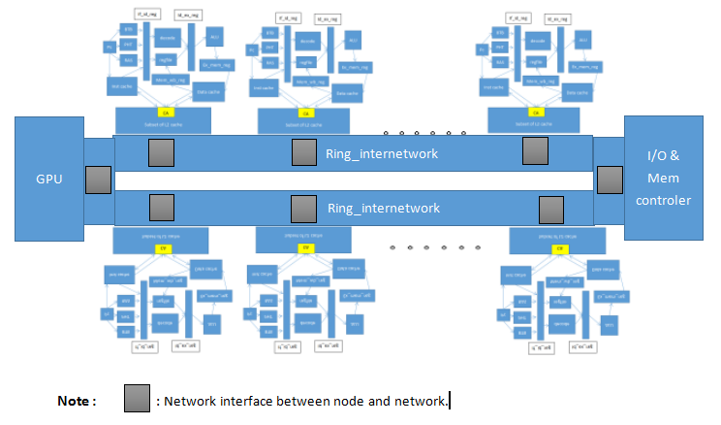

While the GPU can be replaced by other specific function unit. And you can see that you can put more cores on the network if you like easily!

Adding more cores will be supported by define some variable, for instance change core_num from 4 to 8 , if you want to add another 4 cores to the original four-cores system.

You can change network_bandwidth from 16 to 32 if you want to extend the bandwidth of inter_network.

Or you can change some variable of fifo depth in the network to make a exploration for fifo depth.

If any time before I gradute from college or on my job ,I will try my best to make this project more useful for those who want to learn something about computer architecture!

Would you like to support me to do these things sometimes on the fpga platform?

**6.conclusion and suggestion.**

**I think we should encorage those who want to be engaged in computer design to learn knowledge on the hardware platform instead of only doing some emulation on software such as qemu, gem5 or simplescalar , which , i think , will be significant for our design experience, because Imagination had cooperated with Xilinx via MIPSfpga to teach students to learn real world processor design.**

**So,here is my suggestion that you can combine products and knowledge to attract your customers.**

**7.References**

1. **Parallel Computer Architecture A Hardware / Software Approach**

David Culler University of California, Berkeley;Jaswinder Pal Singh;Princeton University with Anoop GuptaStanford University.

**2.Computer Organization and Design The Hardware / Software Interface** David A. Patterson University of California,

Berkeley JohnL. Hennessy Stanford University

**3. 6-823-fall-2005 lecture notes from MIT.**Arvind and Krste Asanovic

**4. CS 152 Computer Architecture and Engineering lecture notes from UCB** 2014-3-6 John Lazzaro.

**5. Parallel Computer Organization and Design**

Michel Dubois University of Southern California (USC)

Murali Annavaram USC ; Per Stenstro¨m Chalmers University of Technology, Sweden

**Appendix:**

My project code on github, **<https://github.com/zhaishaomin/ring_network-based-multicore->**

A floorplan via quartus ii , which is powerful for designing complex digital system!

